36.67: a)
b) 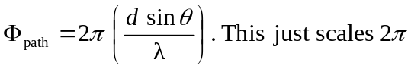radians by the fraction the wavelength is of the path difference between adjacent sources.
If we add a relative phase between sources, we still must maintain a total phase difference of zero to keep our principal maximum.
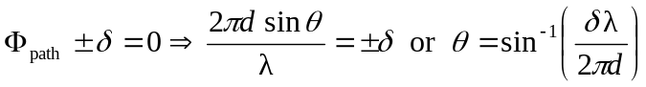
c) 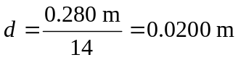(count the number of spaces between 15 points).
